Date
Team Id
Project Name | Optimizing User, Group, and Role  Management with Access Control and Workflows
Maximum Marks

Data Flow Diagrams:
A Data Flow Diagram (DFD) is a graphical representation that illustrates how data moves through a system. It identifies the sources of data, the processes that transform the data, the data stores where information is maintained, and the outputs generated by the system. For the Optimizing User, Group, and Role Management with Access Control and Workflows project, the DFD demonstrates how user information, access requests, approvals, role assignments, and task management flow through the ServiceNow platform while ensuring security and automation.

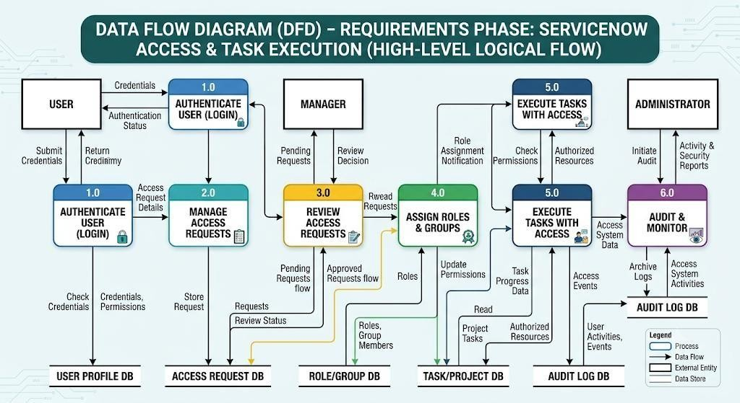

User Stories
User  Story  ID | User Role | User Story | Expected Outcome
US-01 | User | As a user, I want to securely log in to the ServiceNow platform so that I can access  the system using my assigned permissions. | Secure authentication  and authorized system  access.

US-02 | User | As a user, I want to request access to a project, group, or role so that I can perform my assigned tasks efficiently. | Easy submission of access requests with workflow support.
US-03 | System  Administrator | As a system administrator, I want to create, modify, and manage user accounts so that all users have accurate account information. | Efficient user account management.
US-04 | System  Administrator | As a system administrator, I want to create  and manage user groups so that permissions can be assigned collectively to multiple users. | Simplified group-  based permission  management.
US-05 | System  Administrator | As a system administrator, I want to assign roles based on job responsibilities so that users receive only the permissions they require. | Secure implementation of Role-Based Access Control (RBAC).
US-06 | Project  Manager | As a project manager, I want to review and approve access requests so that only authorized users receive access to projects and resources. | Secure and controlled approval process.
US-07 | Security  Administrator | As a security administrator, I want to configure Access Control Lists (ACLs) | Enhanced data  security and controlled access.
User  Story  ID | User Role | User Story | Expected Outcome
 |  | so that sensitive information is protected from unauthorized access.
US-08 | System  Administrator | As a system administrator, I want to automate access requests and approval workflows using Flow Designer so that manual effort is reduced and processing becomes faster. | Automated workflows and improved operational efficiency.
US-09 | User | As a user, I want to receive notifications about my request status so that I always know whether my request has been approved or rejected. |  | Improved communication  and transparency.
US-10 | System  Administrator | As a system administrator, I want to maintain audit logs for all user activities and permission changes so that system actions can be monitored for security and compliance. |  | Complete audit trail and regulatory compliance.

